Modelling real estate taxation and valuation - The case of Denmark

Introduction (Wolters J. and Enemark S. 2002:p. 2)
Denmark is counted among the countries, where is the market value used as a basis for the real property valuation and taxation.

Valuation of real property is carried out by various institutions and for various private and public purposes. E.g., private mortgage companies make their own valuation of the properties prior to determining a mortgage application, and the private real estate agents assess the property value prior to sales or on demand from individuals.
We will focus on the public valuation in Denmark, which is its interaction with the cadastre, the land registry and the municipal property data system.

Valuation for property taxes is a public task and was carried out by layment till 2002, appointed as valuers by the municipal councils. Since 2002 is valuation carried out by employee of Central government.
The purpose of the public valuation is to provide a clear and widely accepted background for calculation of property tax. Property tax comprise 3,5 % of total taxes and duties. Property taxes are divided into property value tax levied by the state and land taxes levied by the county and municipal councils. The land tax rates are each year decided by the local authorities within the range determined in the law.

The county and municipal authorities in Denmark are responsible for utilising more than half of the total public expenditure. Furthermore, the tax income of the counties and municipalities accounts for more than half of the local finances. Annual negotiations take place between the state and the national county and municipal association, in order to determine the guidelines for spending and taxation.

Objective of the paper
The main objective of this description of the Danish property valuation and taxation system is to provide a comparable material to a paper Two-level modelling of real estate taxation - the case of the Czech Republic, and thus contribute to the improvement of the taxation system in the Czech republic

Real estate and taxation in Denmark

The land market in Denmark (Wolters J. 2002)
Denmark’s area is 43,080 km² with a population of 5,3 million inhabitants. Some 65 % of the areas are farmed and 12 % is covered with forest. The remained area of 23 % is used for roads and urban areas. Some 48 % of the Danes live in towns or urban settlements and the average population density is 125 persons per km².
The position of the local government is rather strong - they have 50% of total government expenses.
The participants in the market have public access to information from the Cadastre and from the Land Registry (unique parcel number, boundary demarcation, a name of the owner, address, sizes of area, mortgage, deeds, easements and former sales price). Also, public and reliable information concerning buildings and dwellings are available in the Municipal Property Data System as well as valid public information on land valuation. Finally access to capital and a smooth running banking and financing system is required. Nearly all of this information is now in digital form. Together these instruments provide facts and transparency for the buyer as well as the seller and are supposed to prevent disagreement between the two parties. This is seen as a reason that the number of court cases is rather low.

Existing properties and holdings can be bought and sold free with a few exceptions (special provisions for Summer cottages and non Danish residents, restrictions on purchasing farmland etc.), while sale of parts of properties and holdings are controlled by the provisions of the Act of Subdivision.
The Act of Subdivision ensures properties to be clearly identified and registered. When a part of a property is sold, mortgaged separately or leased for more than 30 years, this part must be subdivided through a formal process. The provisions of subdivision include that spatial planning provisions, as well as provisions regarding to agriculture, and environmental and heritage protection are observed, all public control concerning the objective of the land use.
The Mortgagee (bank, financial institute, individual) finds their basic guarantee in the registration in the Cadastre and the Land Book, which safeguard their interests in the real property against third parties claims of right. The owner finds his basic guarantee in the Constitution and other legislation that protect ownership.

Figures of the land market
Number of parcels and their value:
In 1997 13,356 new parcel numbers derived. The number of parcels is now 2,1 million and the total land value is estimated to 75,000 million USD while the values of the buildings are app. 300,000 million USD. The land and the buildings are mortgaged for a value of 145,000 million USD.

Type of property | Stock | Numbers sold in DKK | Average price in 1000
Residential homes |  | 56,222 | 753
Condominiums |  | 21,233 | 514
Summer cottages |  | 10,132 | 381
Farms |  | 5,287 | 73 (per hectare)
Houses with 2 dwellings |  | 2,243 | 720
Houses with 3 dwellings |  | 324 | 801
Houses with 4-8 dwellings |  | 503 | 1106
Houses with 9 dwellings |  | 282 | 4713
Living houses with store |  | 2,819 | 1523
Trade buildings |  | 1,153 | 4311
Industrial buildings |  | 965 | 4078
Parcels - area below 2000 m² |  | 6,433 | 144 (per m²)
Parcels - area above 2000 m² |  | 1,753 | 56 (per m²)
Table 1: Activity of property trades (1996) (Wolters J. 2002:p.3)

Types of property taxes (Wolters J. and Enemark S. 2002)
In Denmark the personal income tax is by far the most important tax covering 53 % of all taxes and duties. In general the income tax accounts for about half of the gross personal income. Also the "value added tax" (VAT) or general sales tax and the taxes on specific goods (such as spirits, cars, fuel, etc) are important and accounts for 31 % of the total tax and duty revenue. The VAT, being 25 %, covers almost all transactions of goods and services including construction of buildings. The profit from sales of immovable property is not subject to VAT. However, immovable property is subject to a number of other taxes as listed below.

RECURRENT TAXES
Denmark has three types of recurrent property taxes, a land tax on all types of land, a service tax on the value of buildings used for business or administration, and a property value tax on the owner-occupiers of dwellings and summer houses. All three taxes are local taxes levied by the two levels of local government (municipalities and counties).

 | Land tax | Service tax | Property value tax
Official name in Danish | Grundskyld | Daekningsafgifta) | Ejendomsvaerdiskat
Year of introduction | 1926 | 1961 | 2000b)
Coverage | All land | Buildings used for commerce, administration and manufacturing | Owner-occupied dwellings and summerhouses
Basis of tax | Land values  (Capital value) | Building values  (Capital value) | Property values  (Capital values)
Taxpayer | Owner | Owner | Owner
Beneficiary government | Municipalities  Counties | Municipalities  Counties | Municipalities  Counties
Table 2: Overview of the recurrent property taxes in Denmark (Müller A. 2000)

- In Danish the name “daekningsafgift” is also used for the land tax paid for government properties.
- The property value tax replaces - and is very similar to - the income tax of imputed rent of owner-occupied dwellings and summerhouses.

Land taxes
Land tax is levied by the county and municipal authorities based on the assessed market value of the land for all kind of private properties. The tax to be paid to the county councils is fixed by law to be 1 % of the assessed market value of the land. The tax to be paid to the municipal councils is fixed as a part of the yearly total budgeting for each municipality.
The combined tax rate must be fixed within a range of 1,6 - 3,4% of the land value. The average rate to municipalities in 2001 was 1,5 %. The determination of the municipal land tax rate within the prescribed limits is considered an important factor for the local political and fiscal discretion.
There is a payment deferred if owner-occupied dwellings where owner is 65 years or more. The rate is reduced for agriculture, forestry and government as well.
Public properties and other properties such as preserved properties and embassies are not subject to land tax. Publicly owned properties are, however, subject to a service tax meant to cover the costs of public facilities such as roads, parking, fire brigades etc. For state owned properties the tax is equivalent to the land tax. For other publicly owned properties the service tax is normally fixed as half of the land tax. A service tax may
also be levied on certain business properties.
Land taxes account for 13,5 mill DKK (1,6 mill USD) in 2000 equivalent to about 2 % of the total tax and duty revenue.

 | To Counties | To Municipalities | Combined
Maximum | 1.0% | 2.4% | 3.4%
Minimum | 1.0% | 0.6% | 1.6%
Average | 1.0% | 1.3% | 2.3%
Table 3: Land Tax Rates. (Müller A. 2000)

Service Tax
For buildings for private businesses there is no service tax to counties. The service tax to municipalities cannot be more than 1 % of the value of the building. 29 % of the municipalities (mostly urban areas) have decided to levy this tax. Some are using the maximum rate and on average the rate is 0.7 % for those municipalities that levy this service tax.

For buildings owned by the central government the service tax to the counties is 0.375 % of the value of the building. There is no county service tax for municipal buildings.

For buildings owned by the central government or by the counties there might be a service tax to the municipalities at a maximum rate of 0.5 % of the value of the building. 74 % of the municipalities levy this tax, almost all of them at the maximum rate.

 |  | To Counties | To Municipalities | Combined
Business | Maximum | - | 1.0% | 1.0%
Business | Percentage using tax | - | 29% | -
Business | Average for those using tax | - | 0.7% | 0.7%
Government | Maximum | 0.375% | 0.5% | 0.875%
Government | Percentage using tax | 100% | 74% | -
Government | Average for those using tax | 0.375% | 0.488 | 0.863%
Table 4: Service Tax Rates. (Müller A. 2000)

Property value tax
Persons who own their home must pay tax of the value of the home, known as property value tax. The tax is determined and levied by the state government and is included in the total tax payable during the year. The revenue of the property values tax is, however, transferred to county councils (one third) and municipal councils (two thirds).
The tax is currently fixed to be 1 % of the total property value and it is increasing to 3 % for values beyond 3 million DKK (around 350,000 USD). On the other hand, mortgage interest rates are deductible for income tax. Property value tax accounts for 8,500 million DKK (1,000 million USD) in 2000 equivalent to about 1 % of the total tax and duty revenue. The rate for owners older than 67 is reduced to 0,6%.

Basic rates shown in italics |  |  | Properties Acquired before 1/7 1998a)
 | Value up to 2.6 million DKK | 1.0% | 0.8%
 | Value above 2.6 million DKK | 3.0% | 2.8%
Minimum ratesb) for taxpayers aged 67 years or more | Value up to 2.6 million DKK | 0.6% | 0.4%
Minimum ratesb) for taxpayers aged 67 years or more | Value above 2.6 million DKK | 2.6% | 2.4%
Table 5: Tax Rates for the Property Value Tax.(Müller A. 2000).

- There is a further reduction of the property value tax, capped at 1200 DKK, for properties where the calculation of the imputed rent up to 1999 included a fixed deduction for maintenance.

- The reduction of the property value tax for old age taxpayers is capped at 6000 DKK for dwellings and 2000 DKK for summerhouses. The reduction is also depending on the taxpayers taxable income. The table shows the rates for taxpayers that get the maximum reduction.

SINGLE TAXES

Property transfer tax
A conveyance tax must be paid to the Land Registry whenever a property is sold or transferred to another owner. The tax is fixed by law as 1,400 DKK plus 0,6 % of the sales price (at least 0,6 % of the public valuation for the total property value). The tax is due before entering the deed into the land book.
Mortgage document are also taxed when entered into the land book. The tax is fixed by law as 1,400 DKK plus 1,5 % of the mortgage amount. Document of concerning easements etc are subject only to the land book duty of 1,400 DKK.

Development gain tax/betterment tax
This tax is imposed on land being transferred from rural to urban zoning. The change of zoning is the result of an adopted detailed spatial (local) plan transferring a rural zone area into an urban development zone. As a result of the new development possibilities the land value will increase, and a part of this increased value is subject to taxation. The tax is based on the difference between the land value for agricultural use and urban development use. The tax to be paid is 40 % of a difference lower than 200,000 DKK (about 25,000 USD) plus 60 % of amounts beyond this.

Capital gain tax
This tax relates to the profit calculated as the difference between the prices of buying and selling. The profit is included in the basis for income tax. The tax, however, does not relate to properties such as dwellings, summerhouses and freehold flats being used as the home base of the owners. Capital gain tax, this way, only relates to business properties.

Bodies related to real estate taxation - Distribution of Administrative Responsibilities (Müller A. 2000:p.9)
The chapter summarises the most important actors and databases, which keep information on real estate and real estate prices.

The municipalities carry out collection of land tax and service tax. They collect both the municipal taxes and the county taxes.

Central government collects the new property value tax. It is withheld together with the individual income tax. The collection is thus carried out in the same way as for the income tax of imputed rent.
The central government has the responsibility for valuation of immovable property. Originally the Central government appointed 224 Valuation Committees, each had 3 members. Each Valuation Committee was given secretarial assistance by the municipality. In 2002 were the function of Valuation Committees assumed by 15 Property Valuation Boards of appeal, which are nominated by the Ministry of Taxation, among persons proposed by the municipal boards. (Stubkjaer, 2006)

The Central Customs and Tax Administration, which is a part of the Ministry of Taxation, carries out the valuation.

Till 2002, each municipality has a Property Tax Office, which carries out the collection and the secretarial assistance to the Local Valuation Boards. After 2002, the valuation task is performed by government officials.

The basic information needed for valuation and collection is all stored in computerised registers. The Central Customs and Tax Administration maintains a Sales Information Register. The municipalities maintain a Municipal Property Data System (before Valuation and Collection Register). This register includes description of the land parcels, which come from the National Survey and Cadastre. The municipalities maintain a Building and Dwelling Register containing the description of the buildings and dwelling units.

The Ministry of the Interior legislates about the land tax and the service tax while the Ministry of Taxation is responsible for legislation about the property value tax and the legislation about valuation.

Valuation in Denmark (Wolters J. and Enemark S. 2002)

Property valuation principles
A general valuation of all properties in Denmark was previously carried out every four years. In the years in between the general valuations the valuations were updated using factors reflecting the price index development. By 1st January 1996 the 20th general valuation in Denmark took place. Since 1998 annual valuations have been introduced to replace the 4-year valuation system.

years | period
1903 - 80 | every 4 years
1981 - 97 | every 4 years  - indexation in other years
1998 - 2002 | every year
2003 - | every 2 years  - indexation in other years  - dwellings one year  - business and agric. next year
Table 6: Valuation cyrcle (Müller A. 2005:p. 8)

The basic valuation principles are that values for each property are assessed for the total property (land and building) as well as the land. The total property value is assessed as the full market value of the property including land and buildings but excluding machinery, furniture and animals. The value is assessed to reflect the average cash payment that a sensible buyer would pay for the property at the time of valuation. The value should also reflect the best possible economic use of the property.
All public regulations such as planning regulations, preservation of buildings or nature, and rent control - must be taken into consideration. General easements such as regulations for a major dwelling area are also included. Specific private regulations and easements are, however, not taken into consideration. This means that any unusual rent agreements or mortgage conditions should not influence the valuation.

The land value is assessed as the full market value (assumed cash payment) of the land without the buildings or other constructions facilities. Again, the value is assessed to reflect the best possible economic use of the land - disregarding any existing buildings and the present land use. All public regulations concerning the land-use – but not the buildings - are taken into consideration. The land value includes all kind of site improvements such as drainage, sewerage or roads.

The sales approach is the preferred method and is used for those types of properties where there are enough open market sales. The income approach is used for rented properties where sales are infrequent, and the cost approach is used for any remaining types of properties.

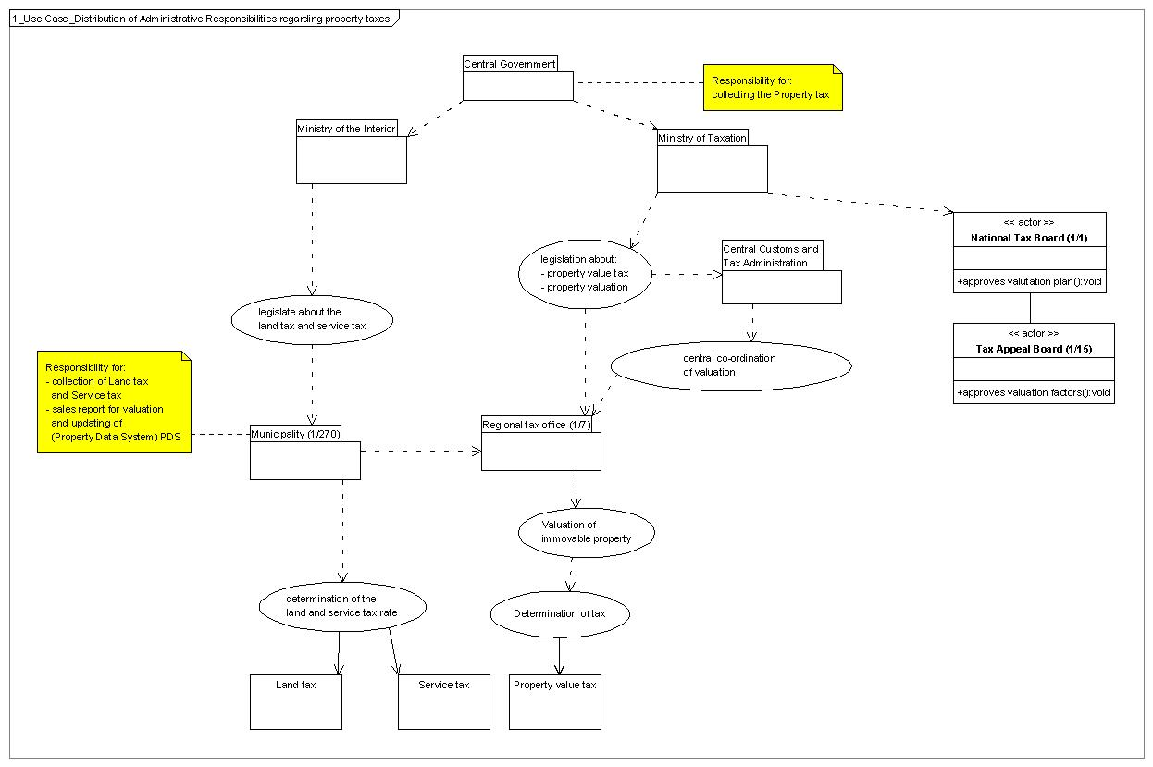
Figure 1: Use Case diagram - Distribution of Administrative Responsibilities regarding Property tax

The valuation process
Before 1980 the first step of the valuation process was to send out forms to the landowners, asking them to fill in all the basic information about the land and buildings and then return the forms to the valuation authorities.
During the 1960´s the valuation process was supported by valuation maps, and by computerised forms, which ware sent to owners for completion. According to the law on Buildings and Dwellings of 1976, the owns for the last time. All necessary information about land and buildings are already recorded and continually updated in the computer registers. Information needed for the valuation process derives from three sources:

- The Municipal Property Data System (ESR)(till 2002 The Register of Properties)
- The Building and Dwelling Register (BBR)
- The Sales and Valuation Register (SVUR)

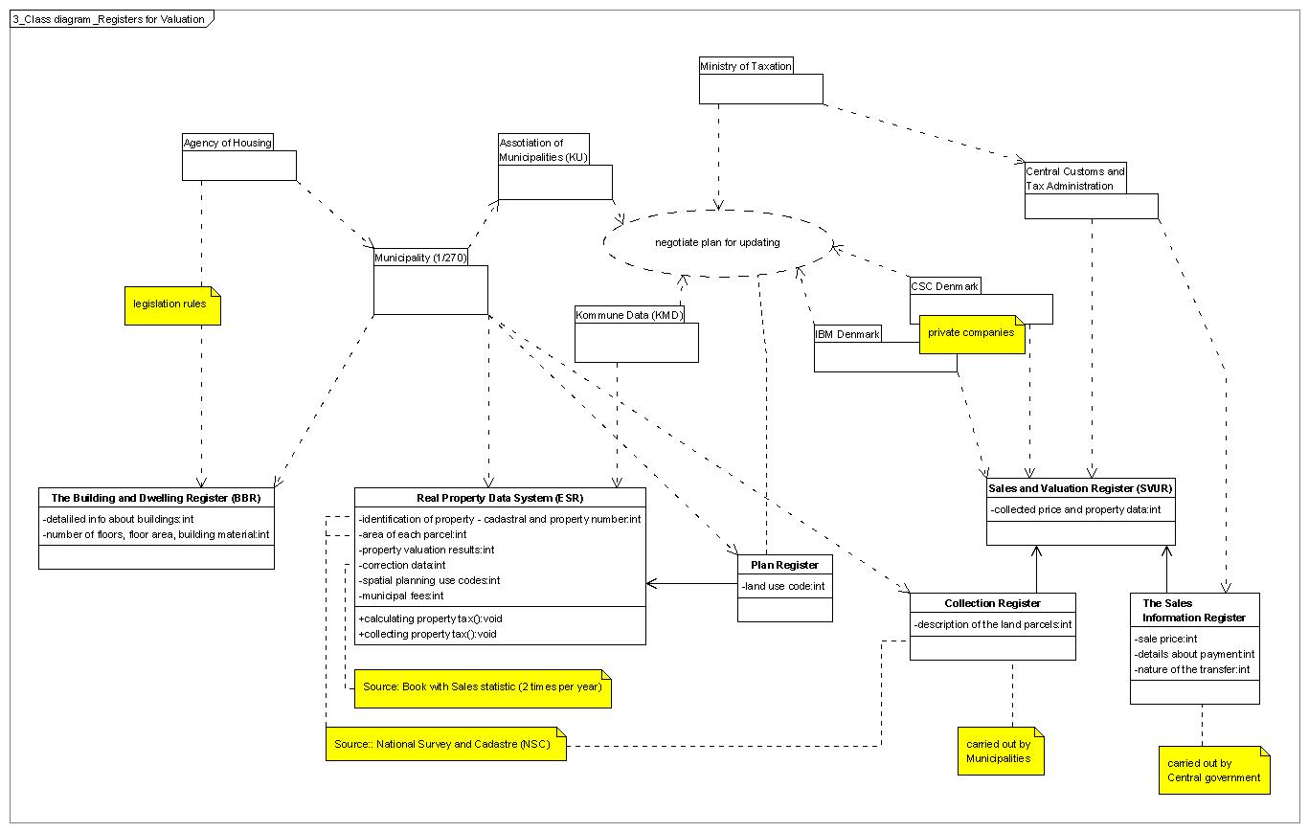

Figure 2: Class diagram - Registers for Valuation

Municipal Property Data System (ESR)
The purpose of the Municipal Property Data System is to record the valuation of each property and thereby assist the authorities in calculating and collecting property taxes. The register contains information concerning identification of the property (cadastral number and property number), area of each land parcel, and the resulting land and property valuation. The register is maintained by the local authorities - the 270 municipal councils. The guidelines for running the register are determined by the Central Customs and Tax Administration of the Ministry of Taxation.

The Building and Dwelling Register (BBR)
The Building and Dwelling Register was established 1977-79 and is based on the valuation forms from the 1977-valuation. The register contains detailed information about the buildings such as number of floors, floor area, and building materials. By establishing the register the owners were informed about the recorded contents, and they are informed when any changes occur. The register is controlled and continuously updated by the municipal housing authorities as a part of their daily routines of issuing building permits.

The Sales and Valuation Register (SVUR)
The Sales and Valuation Register (it is the Collection Register and the Sales Information Register together) derives from sales declarations that the buyer of a property must submit to the municipal authorities during the process of conveyance. The declaration states the sales price, details about payment and the nature of the transfer (open market sale, heritage, family transfer, auction). The deed cannot be registered in the Land Book unless it is proved that the sales declarations have been submitted to the municipal authority. SVUR is used for CAMA as well for an individual valuation.

Statistical information from the three sources is used in calculating the proposed values for as well the total value as the land value.

The landowner may appeal the result of the valuation and classification according to property type. Until 1996 the notifications to the owners contained only information about the assessed values. This caused a large number of appeals without any specified reason. At the 1996 general valuation the notifications were extended. They now include all information and calculations used in the valuation process.

The valuation organisation
The valuation authority is a Central government alone. Only in years 1979 - 2002 was valuation authority local government as well.
As of 2002, the property valuation organisation was deregulated by abolishing the Valuation Committees as well as the Supervision valuation boards. Instead, responsibility for the valuation process will be placed at the 7 Regional Custom and Tax authorities. Furthermore, 15 regional Regional Tax Appeal Boards, each with five members, will be established to deal with complaints from the landowners. Also the valuation process will be simplified.
The Central Customs and Tax Administration acts as a secretariat for the National Tax Board.
Is the Regional Custom and Tax authorithy (1/7) the same as the Regional Tax Office?

Valuation staff

office | numbers of staff
1 Central office | 16
8 Regional offices | 150
7 Regional appeal boards (77*) | 20
7 Appeal secretariests | 25
total | 211
Table 7: Full-time numbers (Müller A. 2005:p. 10)
*This number is full only during the valuation activity
The educational backgournd is based partly on Universities, like law and economics (20%) and partly on the training withing the service (80%)

Appeals
The levels for appeals are next:
- Regional Appeal Boards (7) is it part of the Regional Tax office ????
- National Tax Appeal Board (1)
- Court system - only legal questions
FIRST VER.:
In practice the first instance for appealing of owner is the valuation authority (Regional tax offices - RTO). The deadline for appealing is 3 months after notification of property values (tax) ??. The RTO make a observing of the valuation and look for the arguments, it the valuation was correct or not. If the RTO find that the taxpayer was right, they will assess a new value of the property and they will return the tax overpayment. In standard cases is possible to appeal one year back, but in pollution cases is it 10 years?? years back (does not matter, if there was a different owner then is the currently one). If the RTO disagree with the taxpayer and insists on the valuation, taxpayer can appeal to the Regional Tax Appeal Board and the last instance is the National Tax board. Most of the appeal cases (85 %) are solved at the first instance, thus by Regional Tax office.
A refundable fee 100 EUR for appeals to NTAB and costs of advisor are refunded, if appeal is successful.
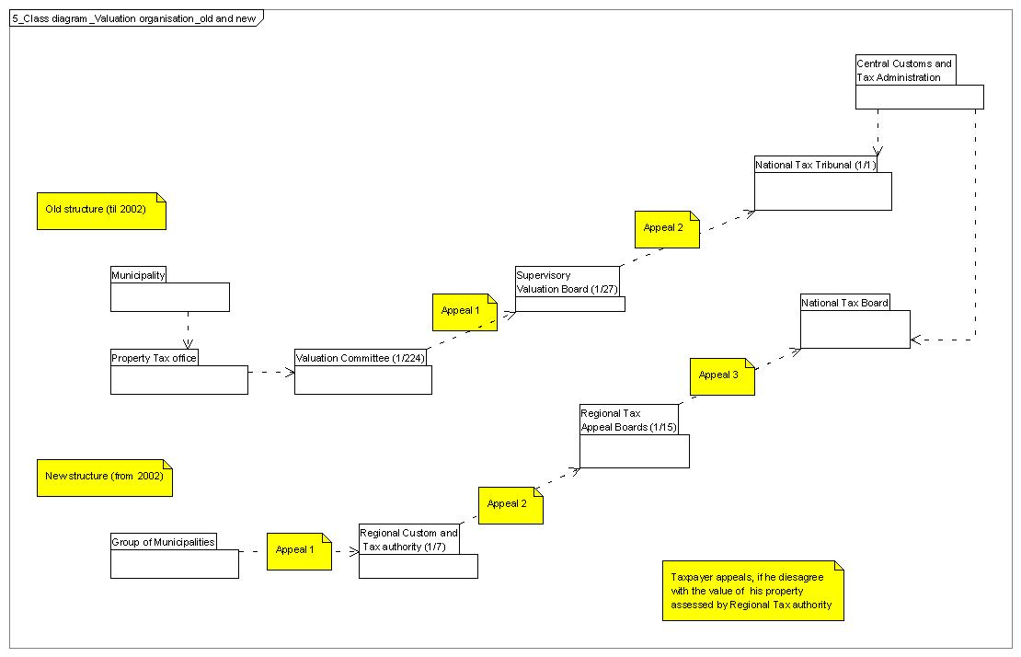

Figure 3: Class diagram - Changes in the Valuation organisation (consultation - Muller, 2006)
SECOND VER.(correct):
In practice the first instance for appealing of owner is the valuation authority Regional Appeal Boards (RAB), which is a part of the Regional Tax office). The deadline for appealing is 3 months after notification of property values (tax) ??. The RAB make a observing of the valuation and look for the arguments, it the valuation was correct or not. If the RAB find that the taxpayer was right, they will assess a new value of the property and they will return the tax overpayment. In standard cases is possible to appeal one year back, but in pollution cases is it 10 years?? years back (does not matter, if there was a different owner then is the currently one). If the RAB disagree with the taxpayer and insists on the valuation, taxpayer can appeal to the Ntional Tax Appeal Board and the last instance is the Court. Most of the appeal cases (85 %) are solved at the first instance, thus by Regional Appeal Board.
A refundable fee 100 EUR for appeals to NTAB and costs of advisor are refunded, if appeal is successful.
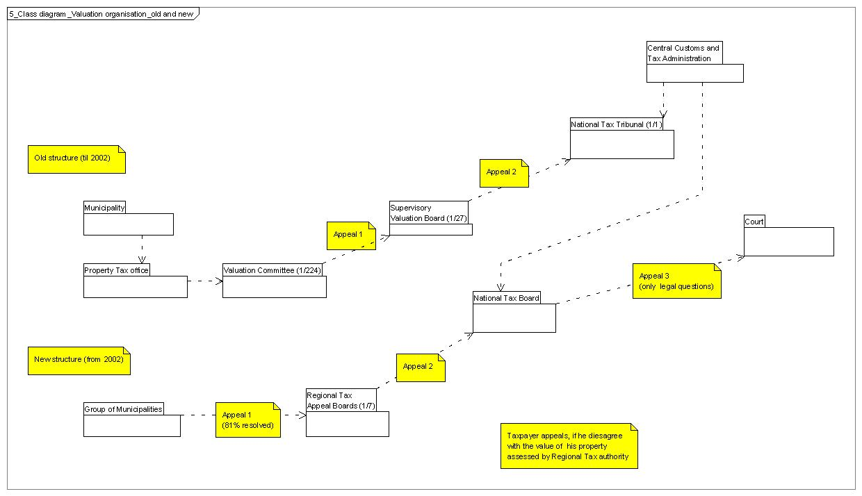
Figure 3: Class diagram - Changes in the Valuation organisation (Müller A. 2005)

 | number | percent
Properties | 1 900.000 | 100%
Appeals total | 39 000 | 2,05%
to Regional Boards | 6 000 | 0,31%
to National Board | 310 | 0,02%
to court system | 10 | 0,00%
Tab. 8: Number of appeals for 2002 valuation

Gathering, analyses and public of market information (Müller A. 2000)
Sales prices are the only direct evidence of the market value of properties. The gathering and analyses of sales prices is therefore the basis for the estimation of market values of immovable property. Rents are an important indirect evidence of market values, and this type of information must also be gathered and analysed. Finally, information about construction costs and depreciation must be gathered for those types of properties where neither sales prices nor rents are available.

Sales report forms
The sales prices are gathered from “Sales report forms”. The lawyer, who carries out the transfer, usually fills out this form and the buyer and the seller sign it. Before the Land Registry can register a transfer the deed must be presented to the municipality. The municipality will ensure that various legal rules concerning agriculture, subdivision and freehold flats are observed, and they will write the latest property value on the deed. When the lawyer presents the deed to the municipality he is required to hand in a filled out Sales report form. The municipality will check that the contents of the sales report form is the same as the contents of the deed and they will write the property number, the property value and the land value on the sales report form.

The municipalities will use the sales report form to update their Municipal Property Data System (ESR) with the name, address and identity number of the new owner. The identity number will be the Civil Registration Number for individuals and the tax identity number for legal persons.

The sales report forms are sent to the Central Customs and Tax Administration who will enter the information into the Sales Information Register. The cash equivalent sales prices will be calculated based on the formal sales prices and the information given on the form about the mortgages taken over as part of the sales contract. It is noted if the sale is an open market sale. This is the case if the parties have not noted on the form that the sale is between family members, an auction sale, an inheritance or a full or partial gift. Sales of one family houses and freehold flats to legal persons are also not considered to be open market sales because many of them will be a transaction between an individual and a corporation that he controls. For rental properties the Sales Information Register will contain the information about the total annual rent (including an estimated rent from the owner). The rent information is given on the sales report form.

The information in the Sales Information Register is used for the following activities:
- Sales statistics
- Sales lists
- Data card for each property
- Analyses for the Property Value System

Sales statistics - on the Internet
The sales statistics are published by Internet pages (www.skat.dk) since 2004 twice a year (formerly was published a 100-page book two times a year as well). The purpose is to inform the public and the Regional Tax Office (before valuation committees) about the trends in property prices. Only open market sales are included. The statistical tables will show the number of open market sales, the average property value, the average sales price and the average difference between the sales price and the property value. The crucial information is the percentage difference between sales price and property value. For the period of a revaluation this figure shows how well the property values correspond to the sales prices. The percentage differences also show the trend in property prices. The trend can be calculated by comparing the figures for the difference for two periods. The publication also includes tables of index figures and graphic representations of the trends in property prices for different types of properties.
The sales lists show the information about all sold properties in a valuation circle. They are sent to the valuation committees to support their estimation of market values.

Finally the sales prices are used for the statistical analyses for the Property value System (see next chapter). Based on the estimated property price trends the sales prices are adjusted so that they correspond to the date of valuation.

Every four years the Ministry of Housing and Urban Affairs will arrange for all owners of rental properties to report the total annual rent (including an estimated rent from the owner). The rent information is recorded in the Building and Dwelling Register and then used for property valuation and for other statistical purposes.

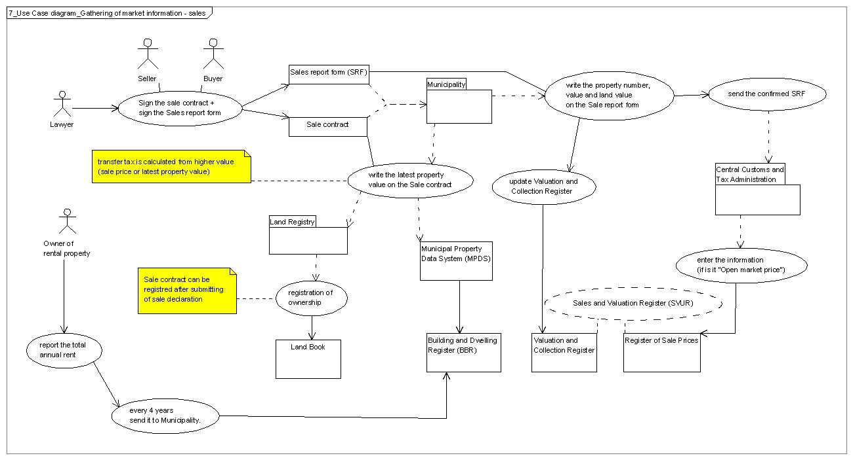

Figure 4: Use Case diagram - Gathering of market information

Information for taxpayers
The Valuation notice was sent to taxpayers by post. Since 1996 must the Valuation notice include details about calculation of values.
Since 1999 are all valuation results on the Internet (www.skat.dk).

Computerised Valuation System (Müller A. 2000)
In the period 1960-1980 computer registers were established containing the description of land and buildings, sales prices, valuation results and identification of the taxpayers. Collection was computerised and valuation notices, valuation list and lists of sales prices were printed by the computer systems.

In 1981 two very powerful valuation systems were established. The two systems are the Land Value System (Grundværdisystemet) and the Property Value System (Forslagssystemet). The two systems are very different in nature and they assist the valuation responsible in different ways.

year | Name of the register
1960 | Land register  Valuation results  Collection of property tax
1967 | Sales register
1980 | Builidnig register (BBR)
1991 | Planning register
1996? | Geographical coordinates
Table 9: Computerised registers (Müller A. 2005:p. 11)

Land Value System (LVS)
The Land Value System ,which was introducted in 1981 and reformed in 1992, calculates the land values based on “pre - assessment” reported by the Valuation Committees (now by the Regional Tax Office - RTO). This way the Land Value System primarily saves the RTO from doing a vast number of calculations. The system also makes sure that the estimation of land values is based on the permitted land use and that valuations vary across the city according to the attractiveness of the areas.

The Land Value System is applied for all properties. The system calculates land values based on reported "prices" or updating factors. Each valuation circle is divided into “land value district” with different permitted land use. The information about the permitted land use is transferred to the Land Value System from the Plan Register. For each land value area one price is reported.

In each land value area the land value for each property is calculated by one of the four “land value models”. The background for using four different models is the observation that the market for land operates differently for different types of land. The four models are:

- One family house model
- Block of flats model
- Agricultural model
- Industrial/public use model

Property Value System (PVS) - CAMA
The Property Value System, which was introducted in 1981 as well as the LVS, is similar to the systems called Computer Assisted Mass Appraisal (CAMA) in the USA. Based on statistical analyses of the declares sales prices they estimate models that are used to calculate property values.
In the Danish language the Property Value System is called the “Proposal System” to underline that the computer generated values 1960 - 2002 were not the final values and that they are a tool for the valuation committees.

The land values calculated by the Land Value System are needed for iterative use for the Property Value System. A revaluation thus has the following phases:
- Estimation of prices for the LVS and review of land value districts.
- Calculation of land values using the LVS and individual adjustments to the land values.
- Estimation of proposed property values using the Property Value System.
- Final decisions about land values, property values etc. by the Regional tax office

The Property Value System is used for one, two and three family houses, freehold flats and summerhouses - that is for 75 % of the properties. The system is also used to estimate the value of dwellings on farms.

For one, two and three family houses and for summerhouses the assessed land values are used in the estimation of the property values. The land values are subtracted from the sales prices. The differences – representing the “sales prices for the buildings” are then used to estimate a model for the building value. The description of the buildings recorded in the Building and Dwelling Register is used. The statistical analysis is carried out using linear multiple regression.
In 2002 the politicians desided to disregard some factors like baths, patio and thatched roof.

Different models are used for different types of properties. The following models were used at the latest valuation in 2000:

- One family detached houses
- One family terrace houses
- Two and three family houses
- Summer houses
- Freehold flats in blocks
- Other freehold flats
- Farm houses

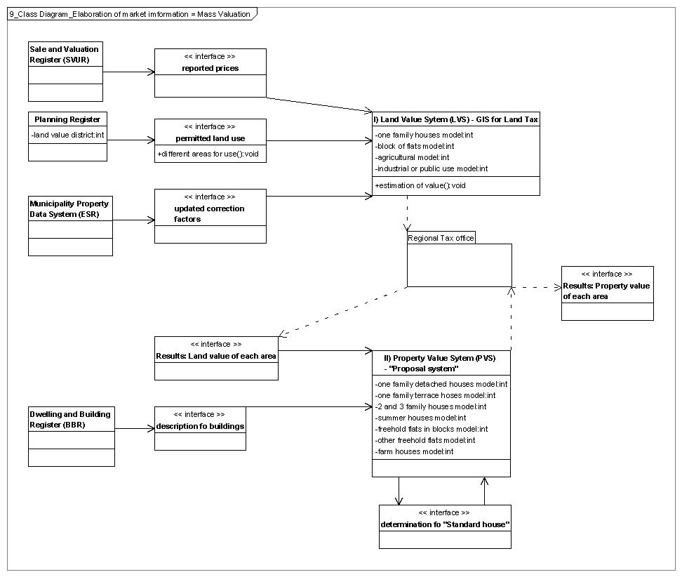

Figure 5: Class diagram - Elaboration of market information = Mass Valuation

Integrated land administration in Denmark
The background to the automated valuation system is the structure of the concept for integrated land management. The concept is organized as a network of interactive subsystems containing the information that are very often used. The automatic linkage between the subsystems is achieved by establishing the "Cross Reference Register" which contains all the key identifications within each subsystem (e.g. the cadastral parcel number, the building number, the postal address) and the cross reference between these
identifications. This means that it is possible to obtain all available information on a specific property or building by knowing only one of the keys. Furthermore, the identification-keys are linked into the relevant physical element represented in the maps, e.g. the building, the parcel or the property. As a basic principle, the subsystems are maintained and updated by the local authorities (custodians) who need the data and therefore care for the updating procedures and the applications as a part of their daily administrative routines.

There are unique links between the Parcel Register, the Digital Cadastral Map, the Land Registry, and the Building and Dwelling Register caused by the cadastral parcel number. Furthermore there are links between the Building and Dwelling Register and the Central Population Register due the unique postal addresses of the buildings. By linking a set of X,Y co-ordinates and thereby establishing a list of geo-coded addresses, it is possible to link any address related information to a map database. This creates a multipurpose information tool for analytical and administration purposes, including valuation and taxation purposes.

 | Danish orig. shortcut | Cadastral identif. number | Property number | Building number | Post | Plan number | Person ID number (CPR)
Cadastre Registry | MR | created | available
Building and Dwelling Reg. | BBR |  | available |  | created
Municipal Property Data System | ESR | available |  | created | created
Planning  Register | Plan-reg. | available |  |  |  | created
Personal Data Register | CPR |  |  |  | available |  | created
Land Register | Tinglsyn. | available
Cross Reference Syst. | KRR | available | available | available | available | available
Sales and Valuation Reg. | SVUR | available | available | available | available | available
Tab 10: Sammenhaengene mellem ejendomsdataregistenes nogler.
Source: GIS in Denmark, 2005, p. 139

Public access to property data (National Agency for Enterprise and Housing 2005)
The National Agency for Enterprise and Housing makes it easier to search and extract property data. The Public Information Server (OIS), is the only collection of property data on the Internet in Denmark. It enables citizens to enquire both on freely available data and on their own property data via the web. OIS gives public authorities, enterprises and citizens efficient access to publicly compiled property data through a single portal and makes data available to distributors who refine and subsequently sell the property data, thereby ensuring competition in this are.

The property data, demanded by public authorities, enterprises and citizens, can be found in central registers hosted by various authorities. The technical basis for open use of the data is still limited as the various pieces of information reside in separate systems with no or little interaction between them.

In the past, the only source for property data was the so-called Transmission System from KMD (Danish IT provider for the public sector). There was no competition and the price on data was high. OIS ensured one common infrastructure in the property area together with a more competitive environment. Due to the data buy-out agreement with the Ministry of Finance, cf. the agreement with the municipalities from 2001, all data in the register is now accessible free of charge. A data-distribution fee is however chargeable to public authorities and enterprises.

Technical solution - XML and web services
OIS offers a number of web services to public authorities, enterprises and citizens. OIS collects and offers access to data along with a description of the data via a standardised interface (XML - Extensible Markup Language). This facility can be extended with further data collection and new services using simple technical tools.

Name of register | shorcut | provider
Danish Cadastre Registry | ? | Government
Sales and Valuation Register | SVUR | Government
Cross-Reference Register | KKR | Government
The Building and Dwelling Register | BBR | Municipality
Real Property Data System | ESR | Municipality
The Register of Plans | - | Municipality
Table 11: Registers contains in OIS
Changes to the register are updated in OIS at least three times a week, so that data are reasonable consistent with the original registers. In the feature, completely updated data will be established through a direct connection to the original registers

Security
A number of precautionary security measures have been taken vis-à-vis using OIS that all meet the demands issued by the Danish Data Protection Agency, e.g. using a common PIN code for access control and the introduction of access to OIS with a digital signature in 2004.

The 2004- version of OIS contains several new functionalities- e.g. a simple way for the owner to update data into the BBR register, as well as online generated status reports and owner notification form BBR. Also, graphic representation of historical sales and valuation data are now available.

Users who retrieve vast numbers of data and use them for business purposes are required to pay a minor fee, while simple queries for private use is free of charge. This way, it has become much cheaper to extract property data, partly due to the buy-out agreement and partly due to OIS´ contribution to creating competition in the field of distributing property data.

References
Müller A. 2000: Property taxes and valuation in Denmark.
Müller A. 2005. Development of Danish Valuation Systems. IRRV International
Conference, Alicante, Spain 22-25 February 2005
National Agency for Enterprise and Housing, 2005: XML offers easier access to
property data
Wolters J. 2002: The Danish way 3 - The land market in Denmark.
Wolters J. and Enemark S. 2002: The Danish way 8 - The property valuation and
taxation in Denmark.

Web sources for property data:
Public information server: www.ois.dk
Tax information server: www.skat.dk

combined rate is rate for municipalities and for counties
The property value is the basis for the calculation of the stamp duty if the property value is higher than the declared sales price.

